**Presentation 1 MOTION NOTES**

**Describing Motion**

* **Newton’s First Law of Motion**
  + An object at rest will remain at rest and an object in motion will continue moving at a _________________________ unless acted upon by a net force.

A. Motion

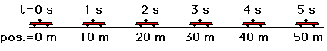

* **Problem:**
  + Is your desk moving?
* We need a **reference point**...
  + _______________________________________________________________
* **Motion**
  + _______________________________________________________________

Distance is how far something has **_____________________________**

* + Measured in **___________________________________________** etc.
  + If you run one lap around a track, you have moved a distance of **___________**
  + If you travel a mile, your distance traveled is **__________________**

Displacement is the **_____________** in position of an object from **_________** to **____________**.

* + Measured in **METERS, km, cm, mm**, etc.

**Problem:**

* You are a passenger in a car stopped at a stop sign. Out of the corner of your eye, you notice a tree on the side of the road begin to move forward.

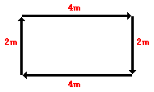

* You have mistakenly set yourself as the

_____________________________.

Unit 8 Day 2



B. Speed & Velocity

* **Speed**
  + __________________ of motion
  + ___________________________________
* **Instantaneous Speed**



* + speed at a given instant
* **Average Speed**
* **Problem:**
  + A storm is 10 km away and is moving at a speed of 60 km/h. Should you be worried?

|  |  |
| --- | --- |
| * + Given | * + Work |
|  |  |

* **Velocity**
  + speed in a given direction
  + can change even when the _____________________!



C. Acceleration

* **Acceleration**
  + the rate of change of velocity
  + change in _____________________________

***a*:** ________________

***vf*:** ________________

***vi*:** ________________

***t*:** ________________

* **Positive acceleration**
  + “speeding up”
* **Negative acceleration**
  + “slowing down”
* Your neighbor skates at a speed of 4 m/s. You can skate 100 m in 20 s. Who skates faster?

|  |  |
| --- | --- |
| * + Given | * + Work |
|  |  |

* A roller coaster starts down a hill at 10 m/s. Three seconds later, its speed is 32 m/s. What is the roller coasters acceleration?

|  |  |
| --- | --- |
| * + Given | * + Work |
|  |  |

* Sound travels 330 m/s. If a lightning bolt strikes the ground 1 km away from you, how long will it take for you to hear it?

|  |  |
| --- | --- |
| * + Given | * + Work |
|  |  |

* How long will it take a car traveling 30 m/s to come to a stop if its acceleration is -3 m/s2?

|  |  |
| --- | --- |
| * + Given | * + Work |
|  |  |

**E. Graphing Speed**

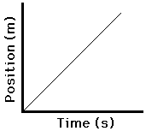

**Distance and Time are __________________!**

**Independent Variable: __________________**

**(X Axis)**

**Dependent Variable: __________________**

**(Y Axis)**

**Reading a Speed Graph Distance – Time Grahp**

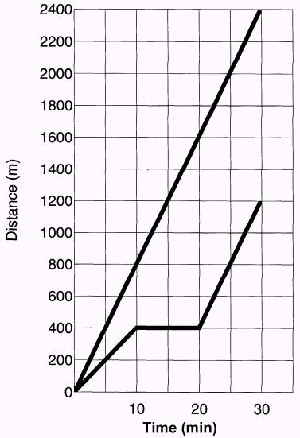

* slope =
* steeper slope =
* straight line =
* flat line =

**Reading a Constant Speed Graph**

* Who started out faster?
  + ________ (steeper slope)
* Who had a constant speed?
  + ____________
* Describe B from 10-20 min.
  + _______ stopped moving
* Find their average speeds.
  + A = ______________
  + A = ____________
  + B =________________
  + B = ______________

**Reading an Acceleration Graph**

**Distance Time Graph**



* Acceleration is indicated by a __________

on a ___________________________ graph.

* Changing slope = _____________________

**Graphing Acceleration**

* slope =

Speed Time Graph

* + straight line =
* flat line =
* E. Graphing Acceleration

Specify the time period when the object was...

* slowing down
  + ______________________________
* speeding up
  + ______________________________
* moving at a constant speed
  + ______________________________
* not moving
  + ______________________________