Magnetism

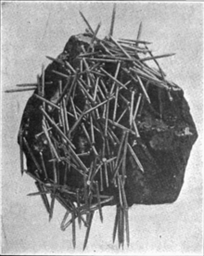
Magnetism
- Discovered by the Greeks in ________________________________, Turkey
- ____________________________________ - magnetic rock; magnetite ore
- Refers to the unseen _______________________ of attraction and repulsion between of magnets
- Magnetic Force – magnets exert force on each other
- The __________________________ they are, the ________________________________ the force
- A magnet is surrounded by a ______________________________________.

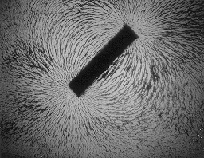
Magnetic Field
- Exerts a _________________________ on other magnets and
objects made of magnetic _____________________________
- Represented by magnetic field lines
- Have _____________________________________

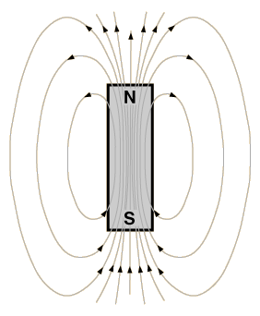
Magnetic Field and Poles
- Poles are where the magnetic force exerted
by the magnet is the ______________________________
- Field lines are ______________________ together
- ______________________________
- ______________________________

How Do Magnets Interact?
- Like poles ____________________
- Opposite poles ___________________________
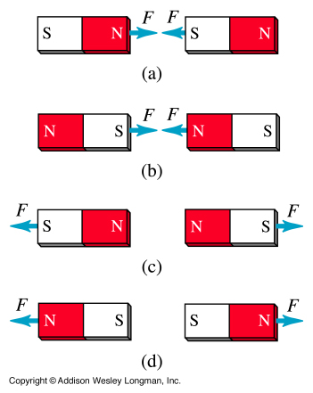
- When 2 magnets are brought close to each other, their magnetic fields ______________________________ to produce a new magnetic field.
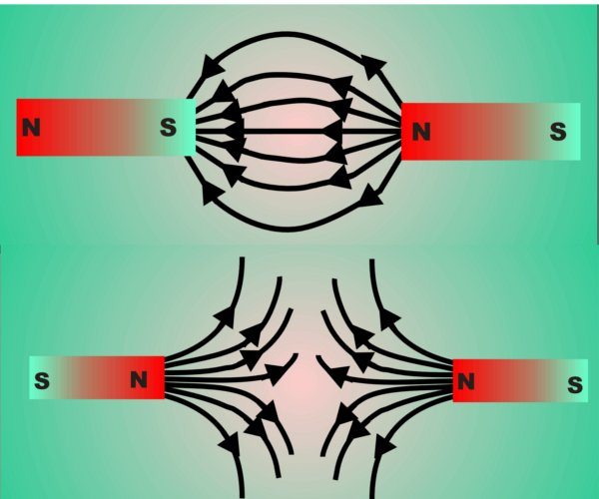

Magnetic Materials
- _________________ (Best) - _______________________ - _____________________________
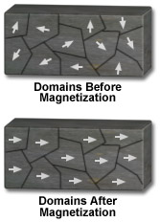

Magnets on the Atomic Scale
- Magnetic Domains: Groups of atoms with _________________________________
magnetic poles
- A non-magnetic piece of iron (ex. a nail) can be made into a
___________________________________________ if the domains are aligned

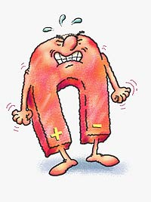

Can a Magnet Lose Its Magnetism?
- _____________
- If a magnet is ___________________________, the atoms can begin to move fast enough to mess up the ___________________________________ of domains

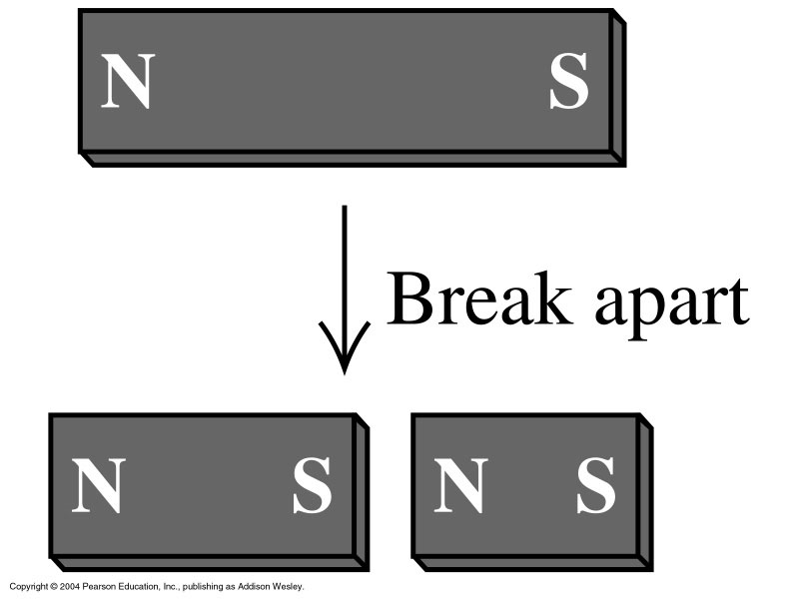
Can a Pole be Isolated?
- ____________
- When a magnet is broken, _________________________________
will still have a north pole and a south pole

Electromagnets
- __________________________________ magnet
- Made by wrapping a _____________________________ around an iron core, and then running a _________________________ through the wire.

