1. Write out the complete definition of a Scientific Theory and a Scientific Law.

2. Why do we use the scientific method?

3. Identify all of the steps in the scientific method.

4. Formulate a hypothesis for the following experiment:
Mike wants to only mow his grass once a month. He has heard of a chemical that will decrease the growth of the grass. He sprays his front yard with the chemical and does not spray the chemical in the backyard. What do you think will happen?

5. What units would be best to measure the mass of a person?
a. grams b. centigrams
c. milligrams d. kilograms

6. Define a measurement standard.

7. Match the measurement with the best instrument

- Volume of a liquid a. Celsius Thermometer
- The width of a small book b. Graduated Cylinder
- Someone with a fever c. Triple Beam Balance
- The length of a desk d. The centimeter side of a ruler
5. Mass of a rock e. A meter Stick

8. In the following chart write the SI base unit for each measurement.

Measurement Base Unit
Length
Volume
Mass
Temperature

9. In the following chart, determine the equivalent.

Length Mass Volume
1000 meters = ______ kilometers | 1000 grams= _____ milligrams | 7.5 L= _____milliliters
100 meters = _____ centimeters | 1.5 grams = _______ decigrams | 7.9 milliliters = ____cm³
10 meters = ________ millimeters
5.5 centimeters = ______ meters

10. Name the lowest part of the curve as shown in the graduated cylinder.
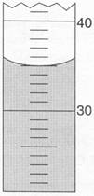

11. Define the independent variable and the dependent variable. When graphing where should each variable be labeled?

Safety. Answer each of the following.
- What is the first thing to do when an incident happens in the laboratory?
- Can you perform any experiment you want in the laboratory?
- Do you know where the fire extinguisher is located? Eye wash? Shower? Fire Blanket?
- What is the rule for smelling chemicals in the laboratory?
- Can you touch or taste a chemical in the laboratory?
- What is the purpose of goggles?
- Check glassware for cracks or chips and let the teacher know immediately. Why is it that you cannot use this glassware in the laboratory?
- Why is it necessary to pull hair back while using a Bunsen burner in the laboratory?
- With a Bunsen burner, you must light the match first and then turn the gas on. Why?
- Always point a test tube away from you while heating. Why?

Laboratory Equipment: Label each.
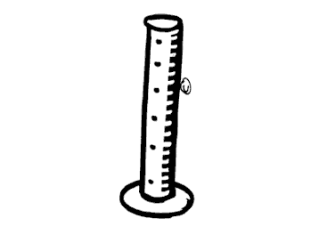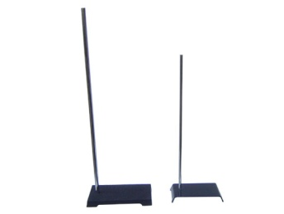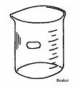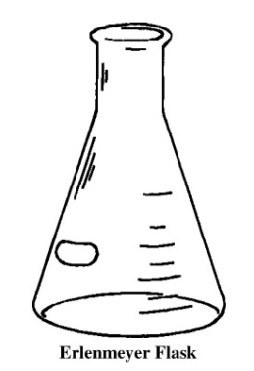
1._______________ 2.______________ 3._______________ 4._______________

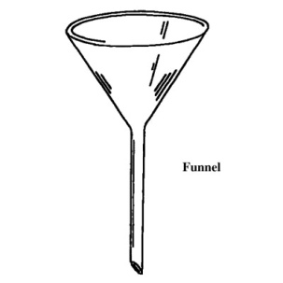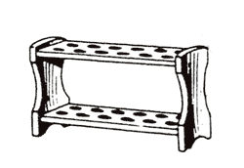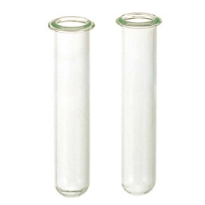

5. _______________ 6. _______________ 7.________________

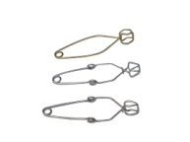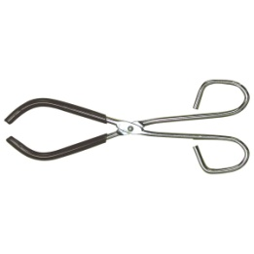

8._________________

Measurement: Write the measurement to the estimated digit with units.

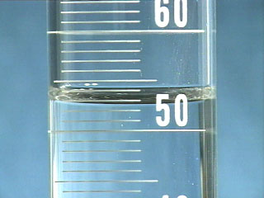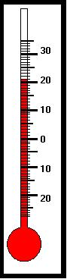

1._______________ 2. _______________

·-----------------------------------· What is the length of this line?
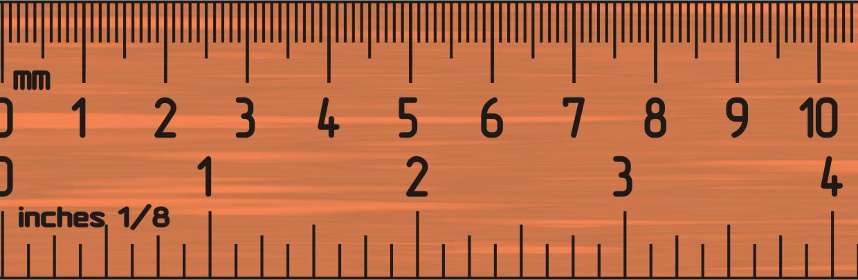

3. _______________

Scientific Notation
Express each of the following in scientific notation.

1. 0.075 cm ____________________ 2. 394 mm ____________________

3. 45 000 m ____________________ 3. 0.009 g ____________________

Express each of the following in standard or expanded form.

4. 7.5 x 10³ ____________________ 5. 8.1 x 10⁻² ____________________

6. 1.7 x 10⁻⁴ ____________________ 7. 5.45 x 10¹____________________

Density. Solve each showing substitutions and all work. Label answer with units.

- Calculate the density of an object whose mass is 5.45 g and volume is 7.5 ml.

- An irregularly shaped object was placed in a graduated cylinder that initially contained 10.0 ml of water. After adding the object, the water rose to 15.5 ml. The mass of the object is 25.34 g. What is the density of the object?

- What is the mass of a cube of zinc whose density is 7.00 g/ml and whose length of side is 3.5 cm.

Temperature

- Convert 23ºC to Kelvin _______________ 2. Convert -43 ºC to Kelvin _______________

3. Convert 274 K to ºC _______________ 4. Convert 451 K to ºC _______________

