Intro to Electricity

Review of the Atom
- Subatomic Particles
- Protons - Electrons - Neutrons
- Electrically ______________________________
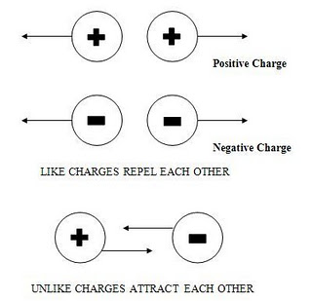
- # protons = # __________________________

Basics of Charge
- Cannot see or ______________________ charge
- Observe its _____________________________ on other particles
- Opposite charges _______________________________
- Like charges _______________________________

Charge Interaction
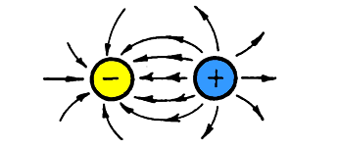
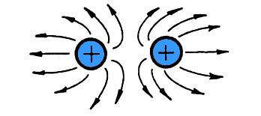

Opposite Charge Attraction
- ________________________ charges = greater attraction
- ______________________ charge = greater attraction

Electric Field
- An electric field extends ____________________________ through space from every _____________________________
______________________________
- As the _______________________________ of the electric field from the charged particle increases, the ___________________________of the electric field _______________________________
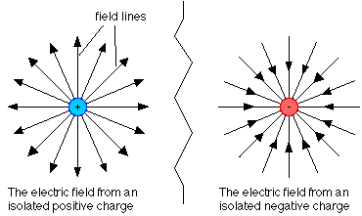
- Electric Field is _____________________________ where lines are _________________________ to each other (closest to the charged particle)

Electricity and the Atom
- In the atom, _____________________________ are free to ______________________(protons can’t because held in the ____________________________)
- Lose electrons = object has ____________________________ charge
- Gain electrons = object has ___________________________ charge
- Atom that loses or gains an electron = _______________

Law of Conservation of Charge
- Charge cannot be created or destroyed.
- It can only be _________________________________ from one object to another.

Conductors vs. Insulators
- Conductor – _________________________ are able to move _____________________ – _________________________
- Insulator – electrons not able to move easily – _____________________, ______________________, ____________________
- Why is this important when it comes to electricity?

Static Electricity
- The ______________________________ of electrons from one object to another without further __________________________________ is called static electricity.
- Static means not moving or __________________________________.
- Static electricity is the build-up of electric charges on an object.
- Once built up, the charges remain at __________________; they do not _________________!

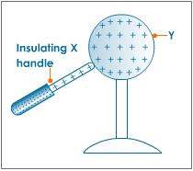
Methods of Charging
1) Conduction
- ________________________________
- Conductors are made of materials that easily conduct electricity
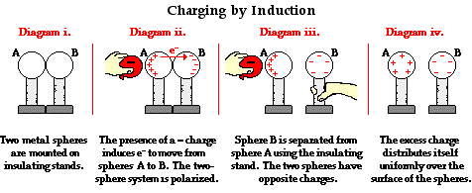

2) Induction
- __________________________________ necessary
- ____________________________ of electric charges

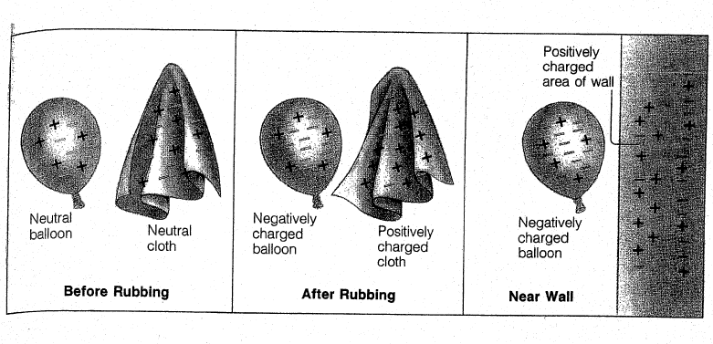
3) Friction
- Rubbing 2 objects together
- One loses electrons, one ___________________ electrons
- Both become __________________________________

Detecting Electric Charge
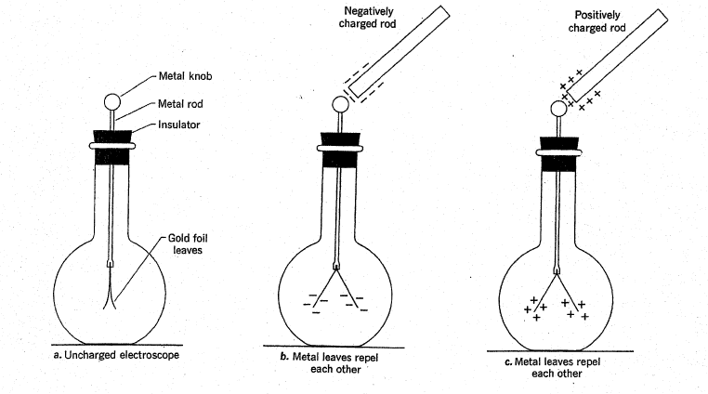
- Electroscope – detects electric charge
- Leaves
- flaps of ______________________________
- hang ____________________________ – no charge
- leaves _________________________ – electric charge present

Electric Discharge
- Charged objects usually ________________ their charge to _____________________ molecules in the air
- Static electricity is more noticeable on dry days. Why?
- Electric discharge is the __________________ of static electricity

Electric Discharge - Lightning
- Static electricity accumulates in clouds from water droplets rubbing against one another
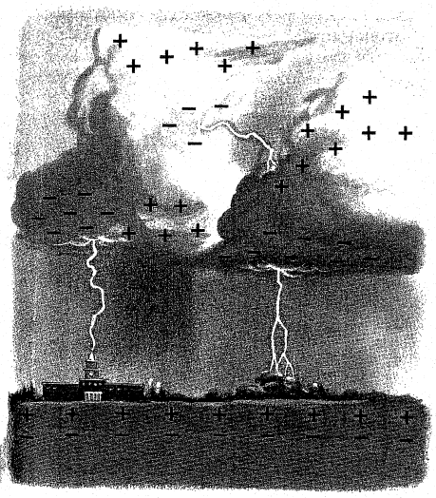
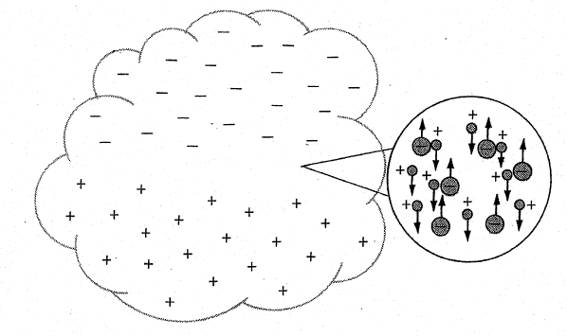
- When the opposite charges between clouds (or clouds and ground) become too great, a tremendous electrical discharge occurs!

Flowing Electricity
- ________________ must be done to move a charged particle
- The amount of work required to move a charge between two points (the work per unit charge) is called the __________________________________________________________
- Measured in ____________________________(______)

Electric Circuits
- A Circuit is when a wire is connected to the terminals of the source to form a __________________________ path that electrons can follow
Electric Current
- A __________________ of charge (_____________________________) is called an electric current
- letter variable = _________
- The amount of charge that ______________________ a given point __________________________________
- The unit for current is the _______________________ (_____) or __________ for short

Resistance to Flow
- Items in the circuit _________________________ the flow of electrons
- ________________/appliance
- ______________________
- The current is __________________________ by interactions with the load and atoms in the wire
- Letter variable = __________
- Unit = ________________ (_______)
- Factors that affect resistance
- Increases with _______________________ wire - Increases with ___________________ temperature
- Decreases with _________________________ wire

Ohm’s Law

Current (l) = amperes
Voltage (V) = Volts
Resistance (R) = Ohms

1) Calculate the voltage difference in a circuit with a resistance of 25 Ω if the current in the circuit is
0.5 A.

2) Find the current in a circuit that has a voltage of 120 volts and a resistance of 60 Ω.

3) Find the resistance of a circuit that has a voltage of 120 volts and a current of 4 amperes.

Ohm’s Law Math Practice Name:
Physical Science
COMPLETE ON A SEPARATE PIECE OF PAPER!!!!!!!!!!!!!!
The speed or velocity of a wave can be found using the following equation:

$$I=\frac{V}{R}$$
I is the current, measured in amps (A)
V is the voltage, measured in volts (V)
R is the resistance, measured in ohms (Ω)

Problems: Work through the following problems. First write the appropriate equation with variables, and then fill in the numbers and solve. Make sure your answer has the correct units. The first one has been done as an example.

- A copper wire is connected to a dry cell battery with a voltage difference of 1.5V. The current flowing through the wire is 1.2 A. What is the resistance of the wire?

- A copper wire is connected to a 1.5 V dry cell battery. The current flowing through the wire is 1.4 A. What is the resistance of the wire?

- A copper wire is connected to a dry cell battery with a voltage difference of 6V. The current flowing through the wire is 1.2 A. What is the resistance of the wire?

- A copper wire is connected to a dry cell battery with a voltage difference of 6V. The current flowing through the wire is 12 A. What is the resistance of the wire?

- A bulb with a resistance of 60 Ohms is in a circuit with a 12V battery. What is the current through this circuit?

  - What is the current if you add one more bulb? (hint: think about what the new resistance will be)

  - What is the current if you add two more bulbs to the original circuit? (hint: you now have a total of 3 bulbs)

- A wire has a current of 6 A and a resistance of 2 Ohms, what is the voltage of the battery it is connected to in the circuit?

- Calculate the voltage difference across a 25 Ohm resistor if a 0.3 A current is flowing through it.

