Electrical Circuits

Electrical Circuits
- A Circuit is a closed conducting _______________________ through which an electric current can ______________.
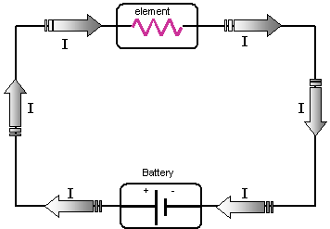

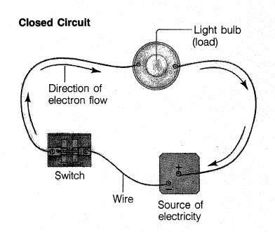
Electrical Circuits - Parts
1) Source of _____________________________ – battery, thermocouple,
electric generator, photocell
2) Resistance (load) – ___________________________ that uses energy –
light bulb, appliance, machine, motor
3) Wires – serves as a _______________ to conduct the electrons
4) Switch – opens (_________) and closes (_______) circuit

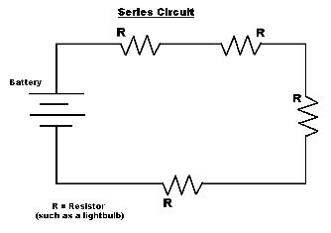
Circuit Diagrams
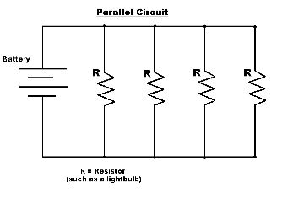

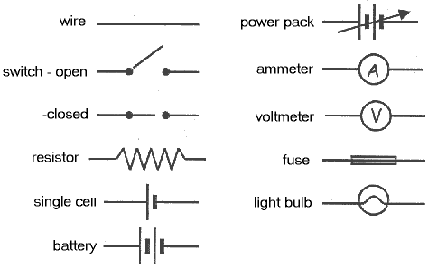
Circuit Diagram Symbols

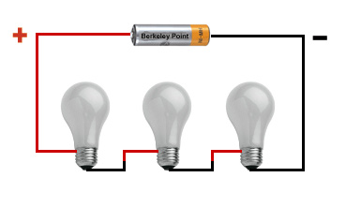
Types of Electrical Circuits
1) Series
- All the parts of an electric circuit are connected
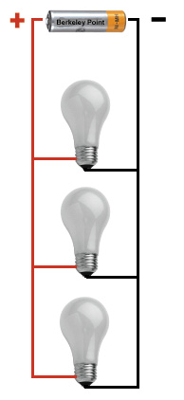
__________________________________________________
- Only _______________________ for the electron to take

2) Parallel
- Different parts of an electric circuit on
___________________________________________
- ______________________________ for electrons to take

Series Circuit
- Disadvantage: if there is a break ______________________________ in the circuit, the entire circuit is open and _____________________________ can flow
Ex: ______________________ holiday lights

Parallel Circuit
- If there is a break in one branch, the electrons and current _______________________________ through the other branches
Ex: _________________________________________ holiday lights

